Jenkins task for Day-02.
===========================

- Configure 2 slave machines in jenkins master.
First creat 3 ec2 instance
- Master in master install >> java prequesite and Jenkins and git

Install sudo yum update –y
sudo wget -O /etc/yum.repos.d/jenkins.repo https://pkg.jenkins.io/redhat-stable/jenkins.repo
sudo rpm --import https://pkg.jenkins.io/redhat-stable/jenkins.io-2023.key
sudo yum upgrade
sudo yum install java-17-amazon-corretto -y
sudo yum install jenkins -y
sudo systemctl start jenkins
sudo systemctl enable jenkins
sudo systemctl status jenkinsJava (Amazon Linux 2023):

after install in Jenkins in master
install git command >> sudo yum install git –y

step: 2
after instllaing java in slave 01 and git ,I created ssh-keygen and

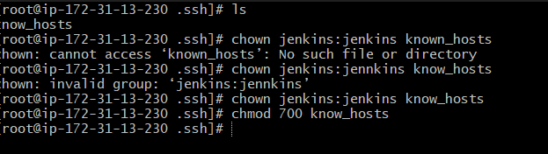
Slave 01

Now to slave 01 ec2
Install java Install Java (Amazon Linux 2023):
[ec2-user ~]$ yum install -y java-17-amazon-corretto

Now do
NOTE:DO SSH-KEYGEN , in the root command
[root@ip-172-31-9-222 ~]# cd .ssh
[root@ip-172-31-9-222 .ssh]# ls
authorized_keys id_rsa id_rsa.pub
[root@ip-172-31-9-222 .ssh]# cat id_rsa.pub > authorized_keys
[root@ip-172-31-9-222 .ssh]# chmod 700 authorized_keys
[root@ip-172-31-9-222 .ssh]# ll

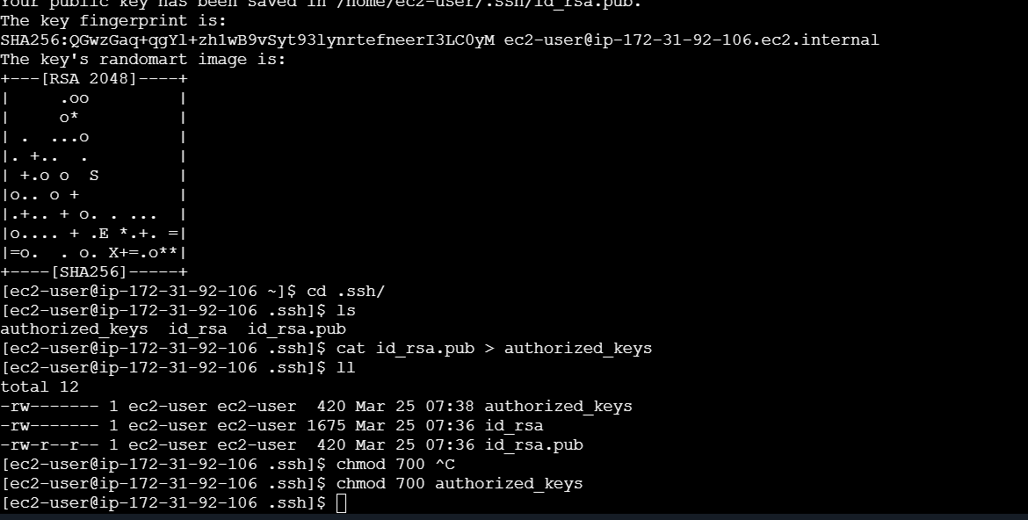

chmod 700 authorized_keys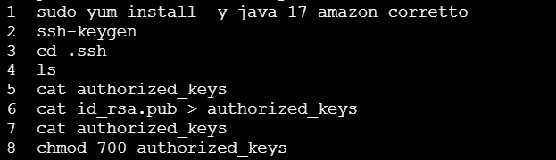

now succefully created a keygen and added permission in slave-01
now go to jenkins master,
create one directiory mkdir .ssh in /var/lib/jenkins/
now go to in to directoy .ssh
cd .ssh
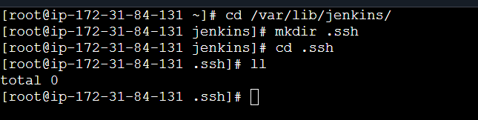
Use this command to in Jenkins master now .
Note: do this below command as root user use (sudo su -)
ssh-keyscan –H 54.89.74.204 >>/var/lib/jenkins/.ssh/known_hosts (N0te : in this command use ip address of slave macheine

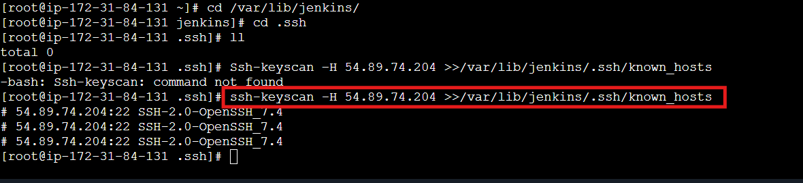
Then change permissions by using command

[root@ip-172-31-84-131 .ssh]# chown jenkins:jenkins known_hosts

[root@ip-172-31-84-131 .ssh]# chmod 700 known_hosts
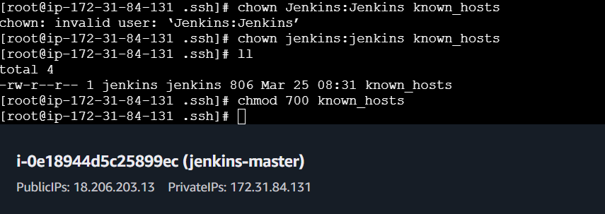

Slave 02
Import step for slave 02
[root@ip-172-31-44-116 .ssh]# ssh-keygen -t rsa -b 4096 -f /root/.ssh/id_rsa_slave02

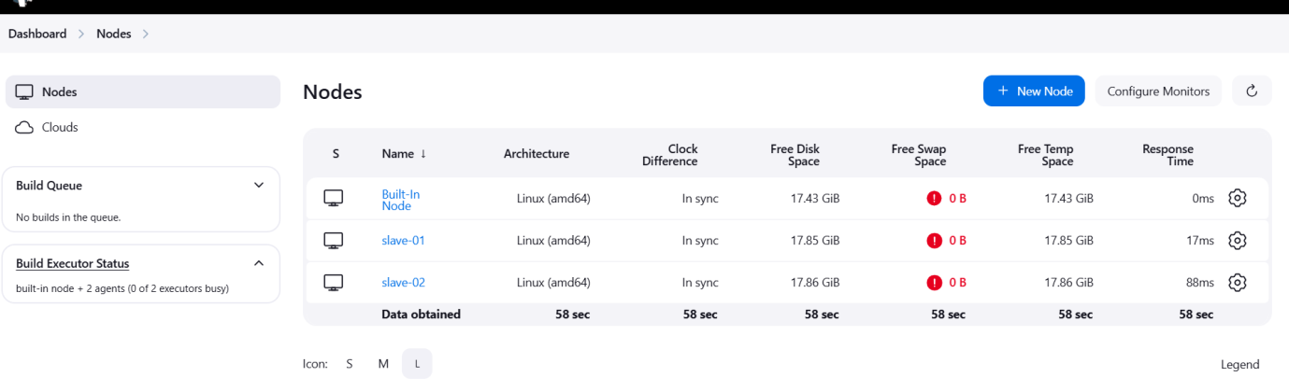

- Configure webhooks to jenkins job.
In this whenever changes in sources , ones we configured , webhook ,it will automatically trigred
Create a repo in github and add webhooks for that repo
Go to settings
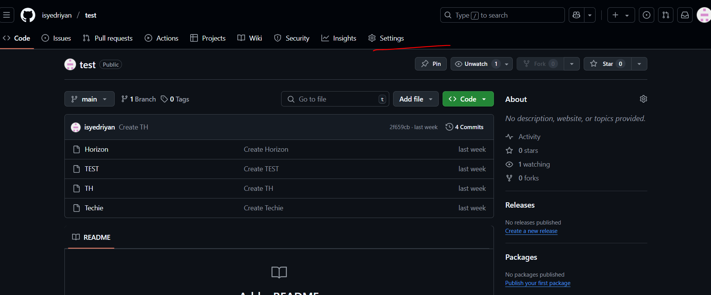
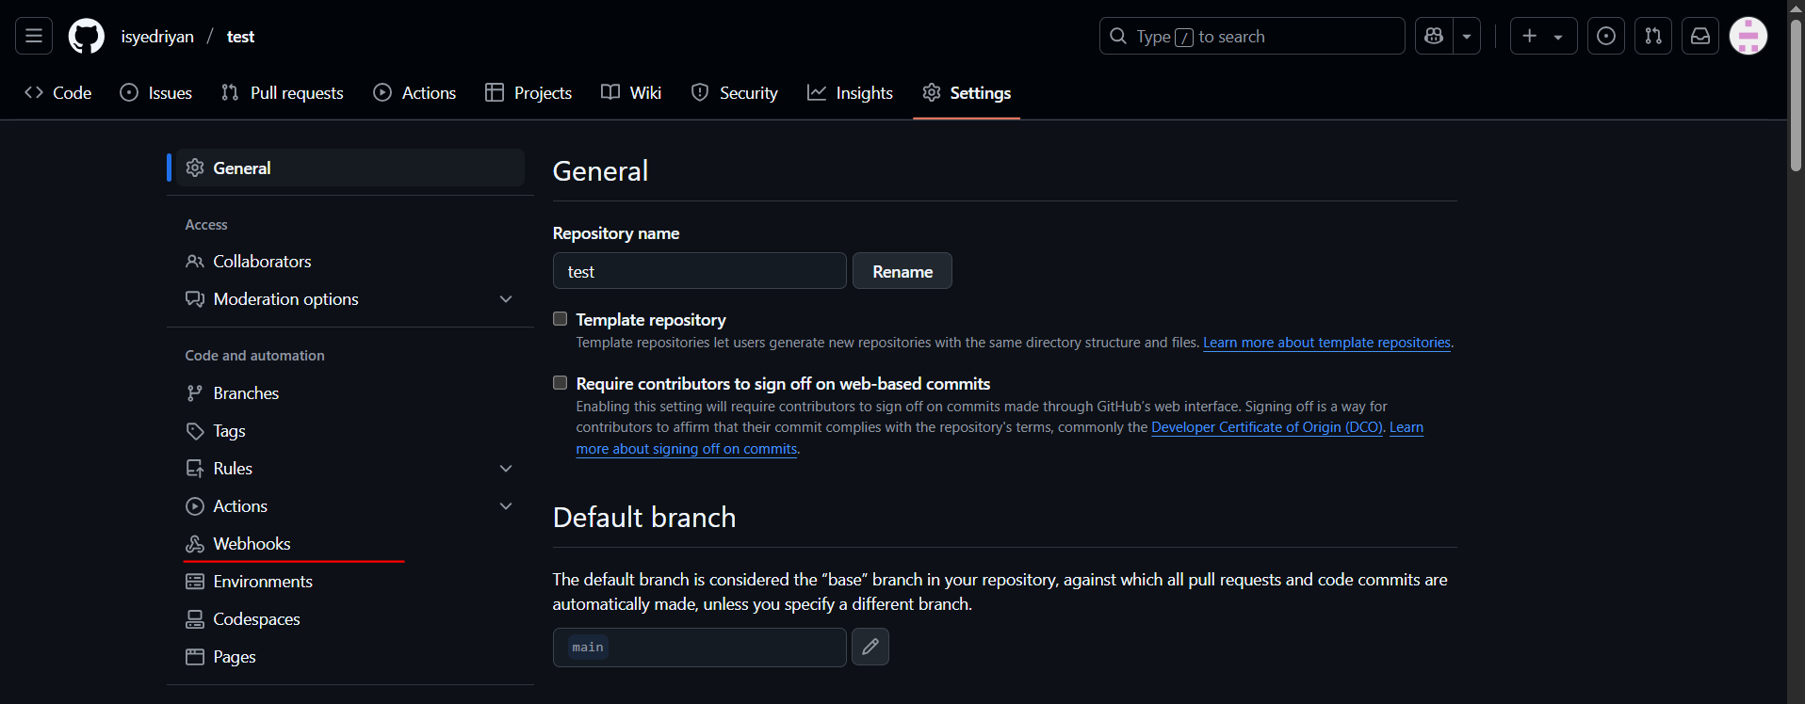
Now go to Jenkins GUI copy the url till 8080 and add in payload url
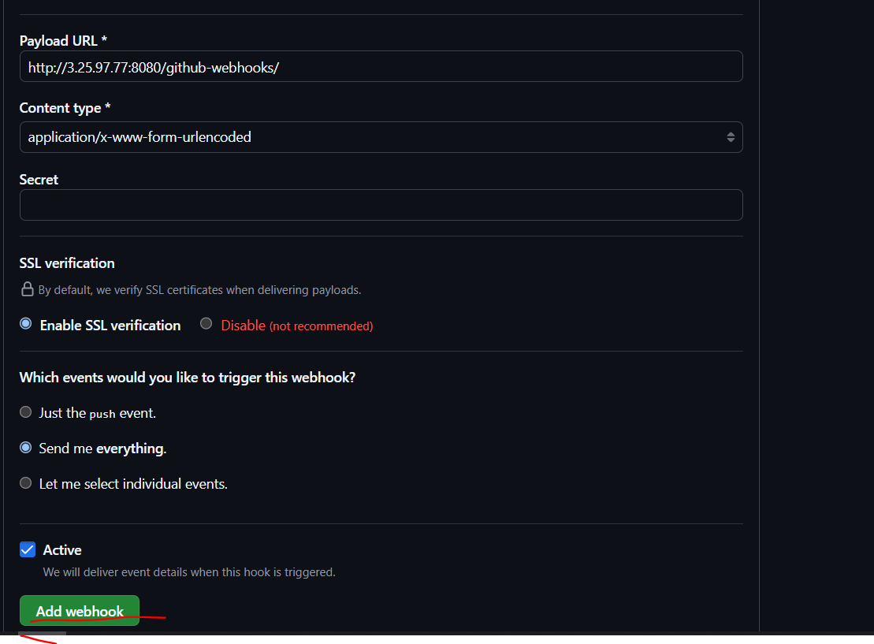

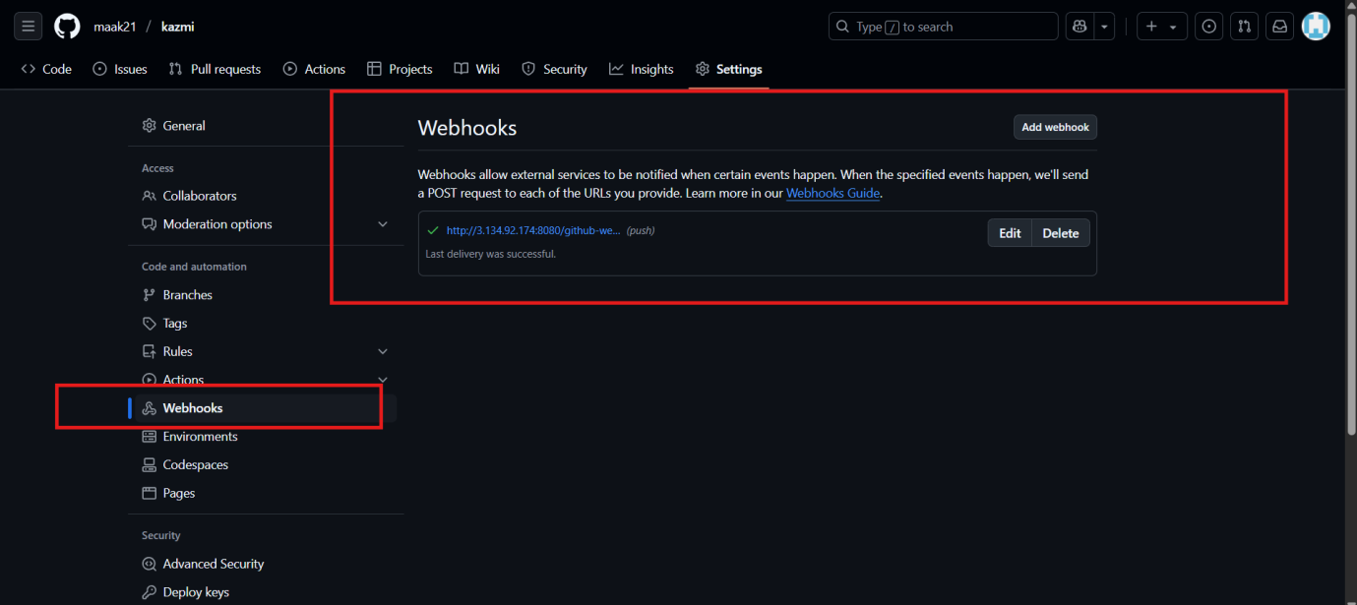
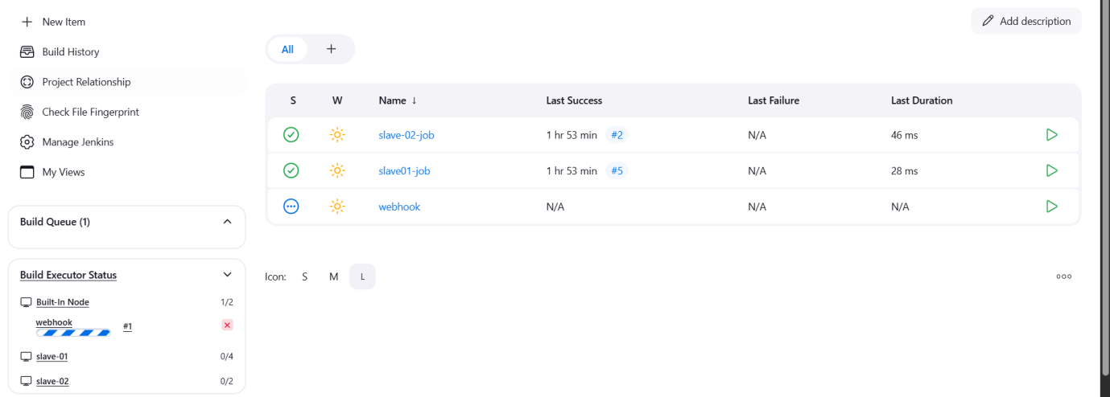

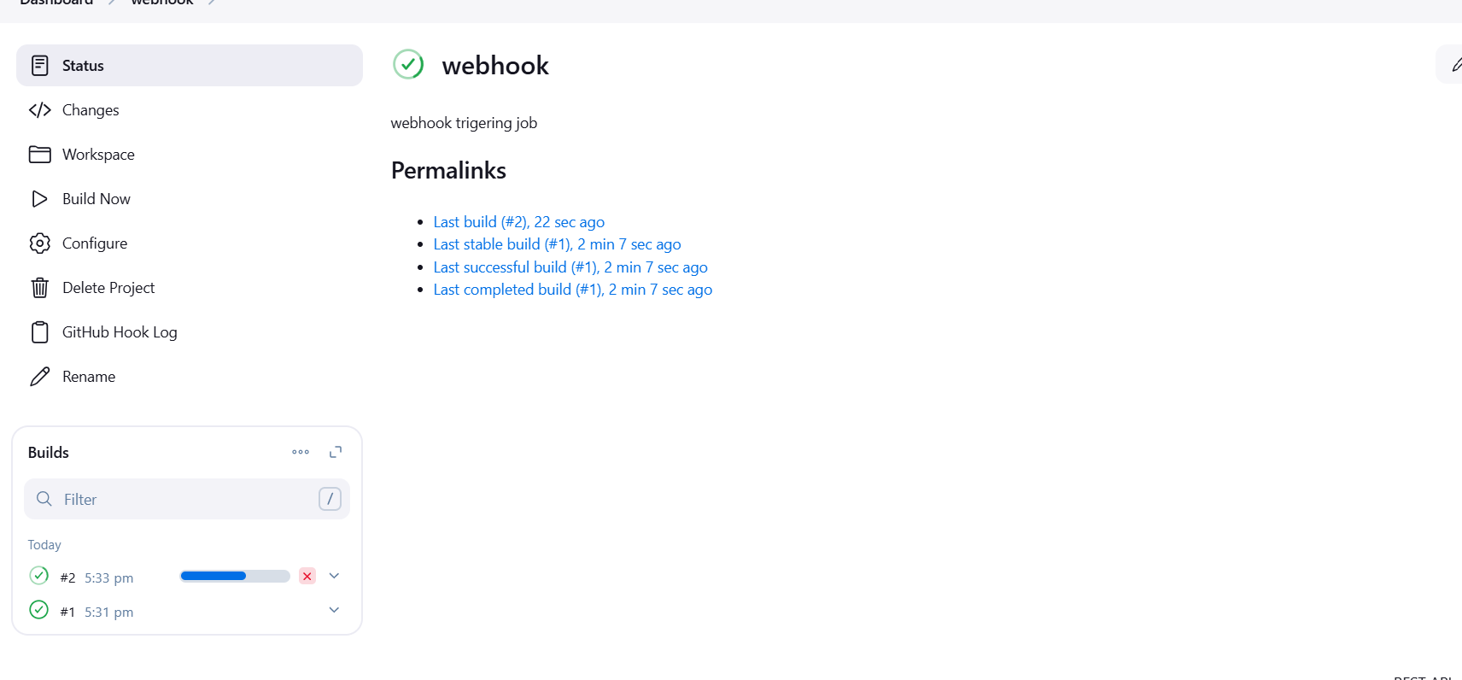
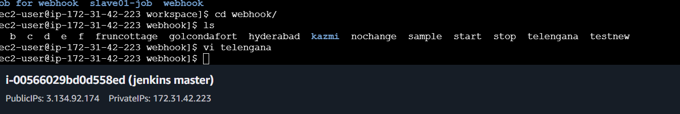
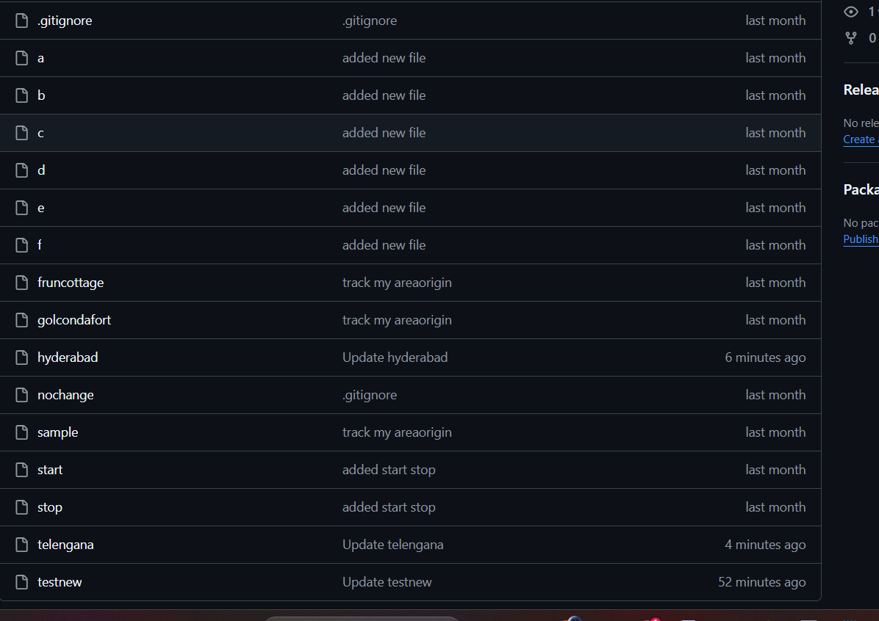

- Configure poll scm and build periodical options in jenkins job.

To build periodically
Click on the job, scroll below and check for Triggers
Under build periodically
Add * * * * *
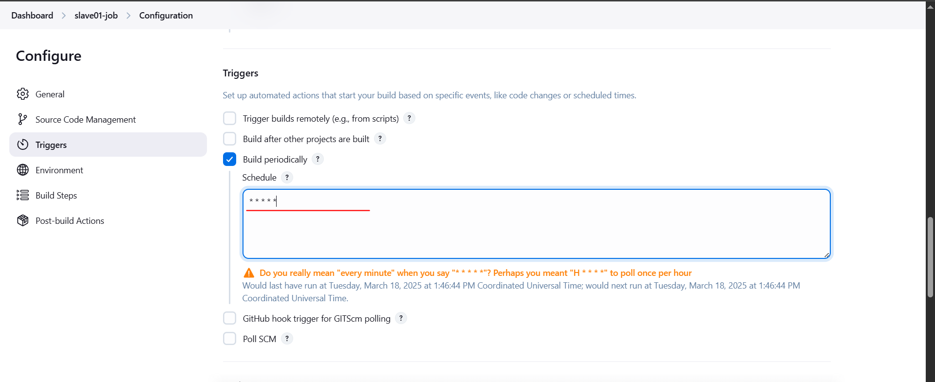
Now wait for 1 minute, it will automatically trigger the job
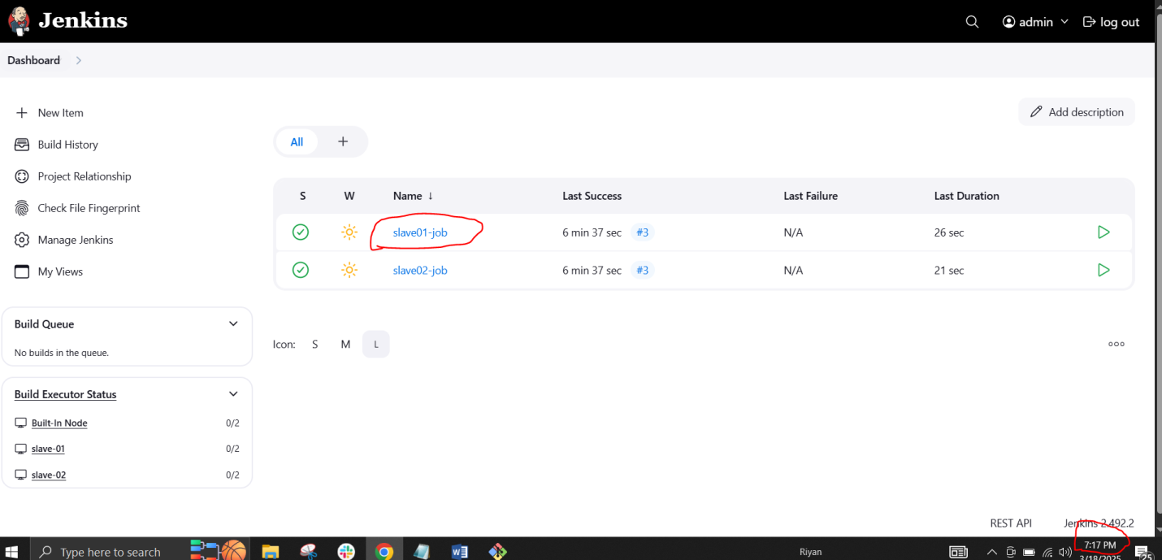

After 1 minute it will trigger automatically
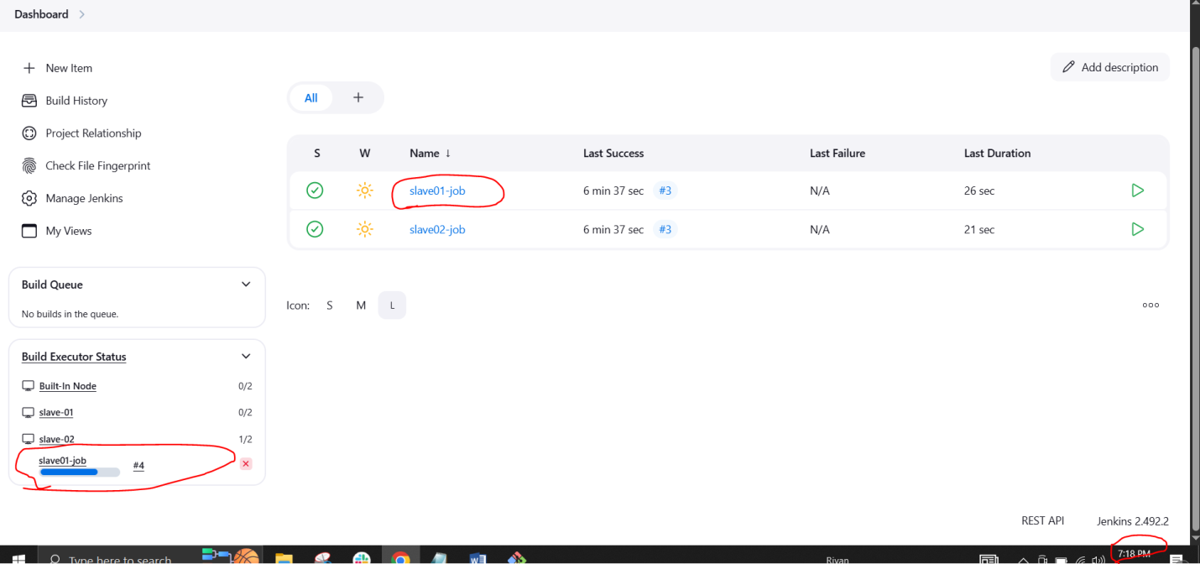
To configure poll SCM
Click on the job, scroll below and check for Triggers
Under poll SCM
Add * * * * *
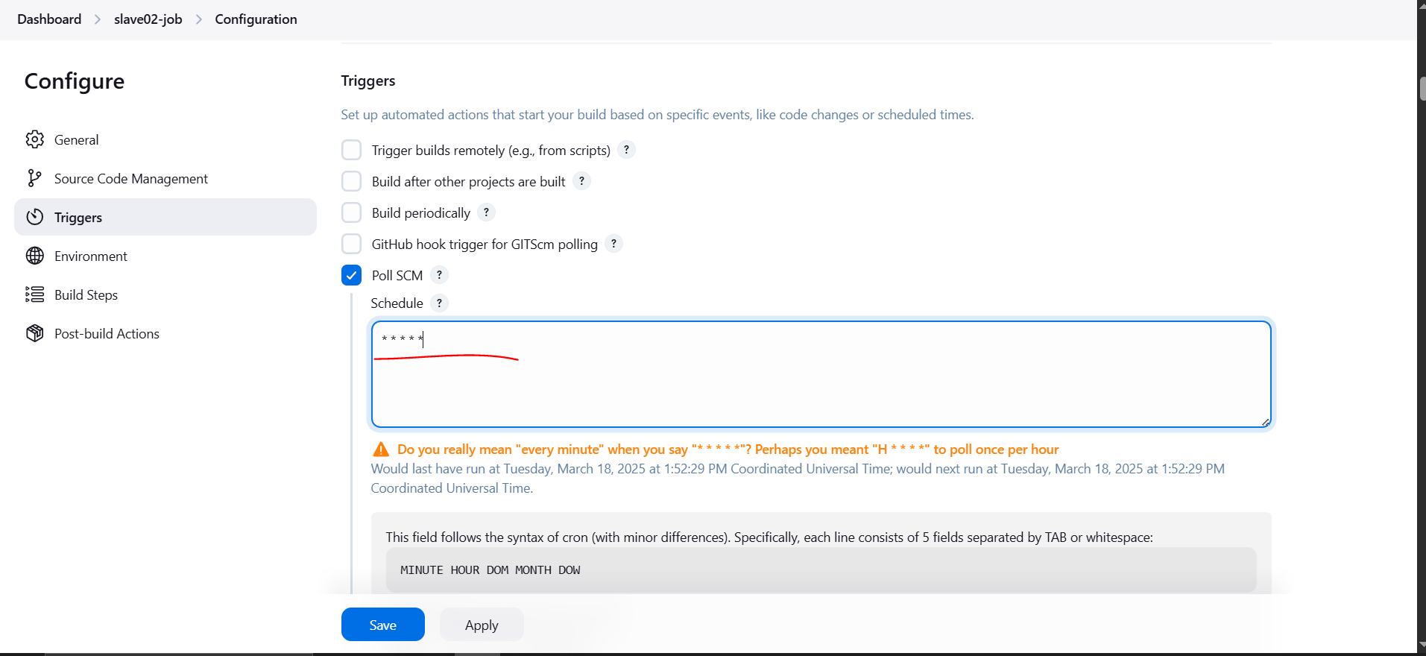

Now go to github and do some changes it will reflect in the Jenkins server
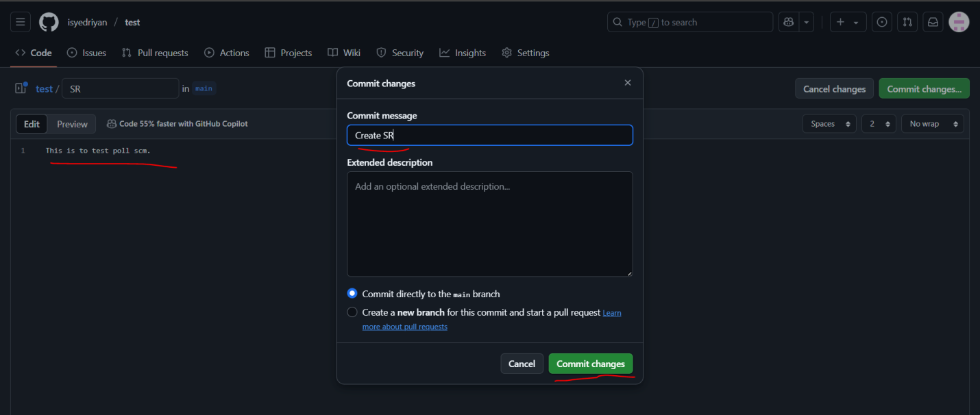

It has triggered in Jenkins server
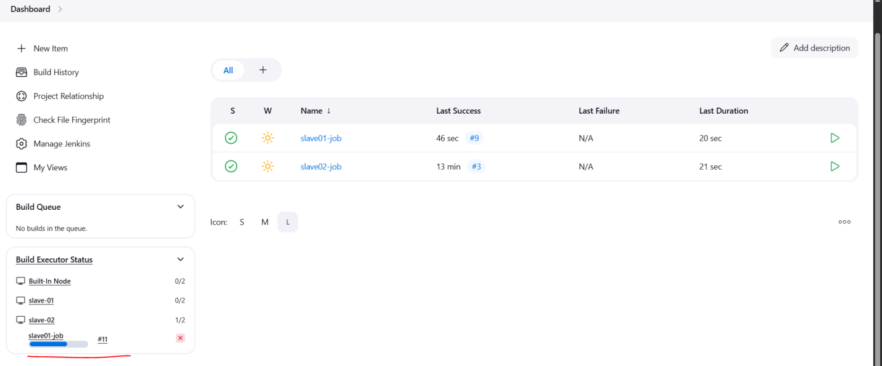

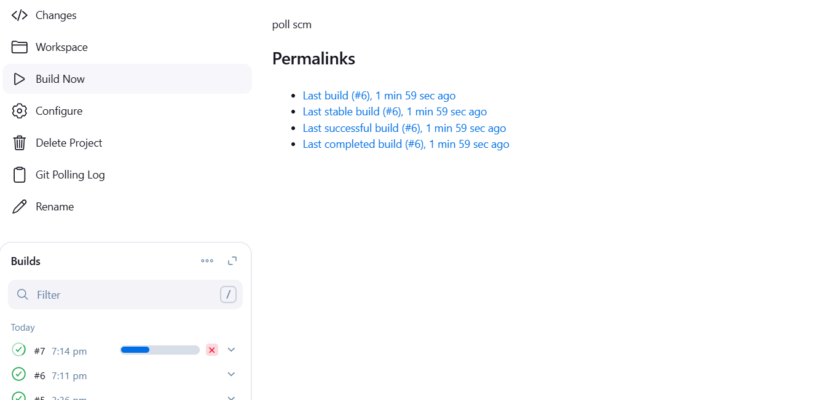

- Take backup of jenkins server by using bash script.

First connect to Jenkins master ec2 instance
sudo –i
Create the script file using the command
sudo vi /opt/jenkins_backup.sh
Paste the script in the file (Jenkins_backup.sh)
#!/bin/bash

# Define backup directory and timestamp
BACKUP_DIR="/var/backups/jenkins"
TIMESTAMP=$(date +"%Y%m%d_%H%M%S")
BACKUP_FILE="jenkins_backup_$TIMESTAMP.tar.gz"

# Create the backup directory if it doesn't exist
mkdir -p $BACKUP_DIR

# Stop Jenkins service to ensure consistent backup (optional)
echo "Stopping Jenkins service..."
sudo systemctl stop jenkins

# Compress Jenkins directory and save it as a backup file
echo "Creating backup..."
sudo tar -czvf $BACKUP_DIR/$BACKUP_FILE /var/lib/jenkins

# Start Jenkins service after backup
echo "Starting Jenkins service..."
sudo systemctl start jenkins

# Verify the backup
if [ -f $BACKUP_DIR/$BACKUP_FILE ]; then
echo "Backup created successfully: $BACKUP_DIR/$BACKUP_FILE"
else
echo "Backup failed!"
fi

# List backups (optional)
echo "Available backups:"
ls -lh $BACKUP_DIR

exit 0

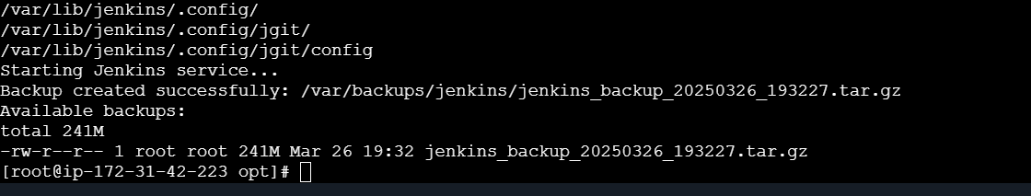
scp -i ohio.server.key.pem /var/backups/jenkins/jenkins_backup_20250326_193227.tar.gz ec2-user@: 13.58.174.58/tmp

ssh -i ohio.server.key.pem ec2-user@3.134.92.174
ls -l /tmp
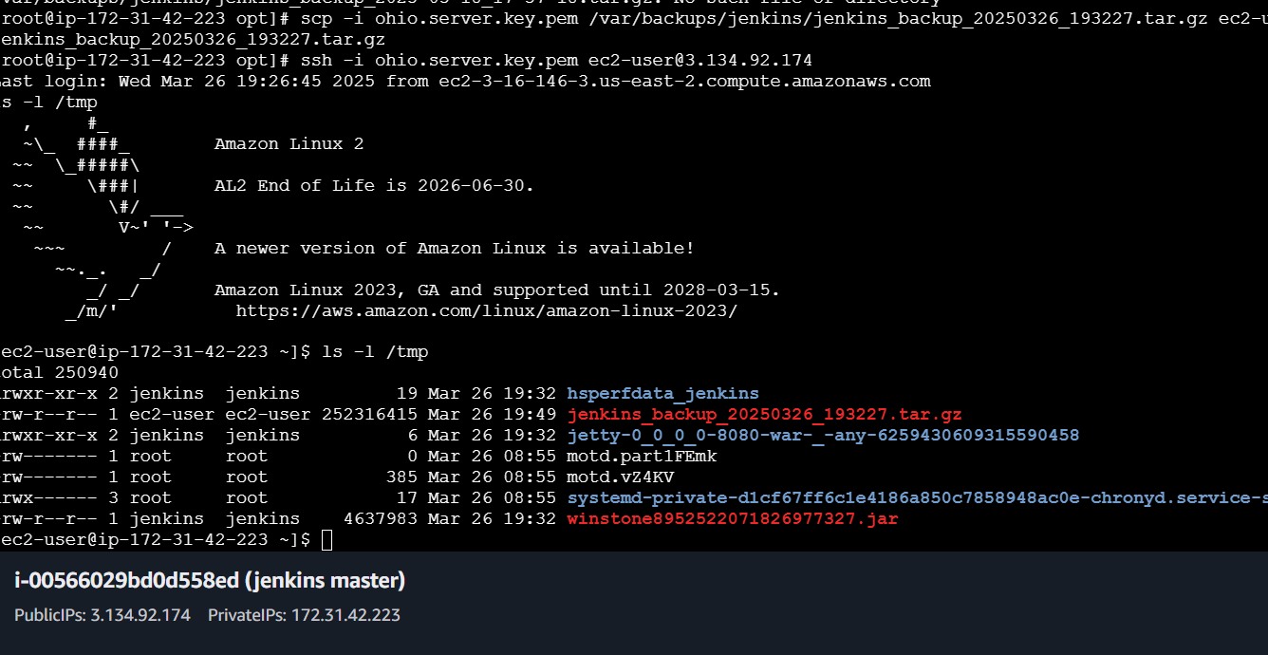

jenkins_backup_20250326_193227.tar.gz

- Take backup of jenkins using rethin backup plugin.
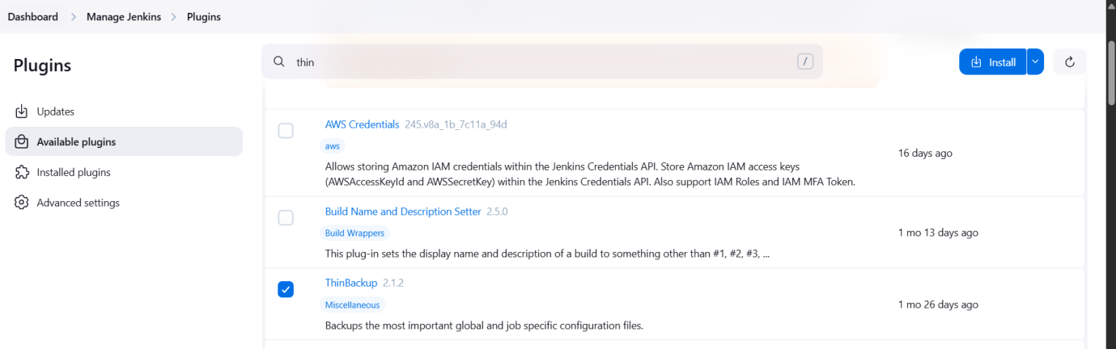
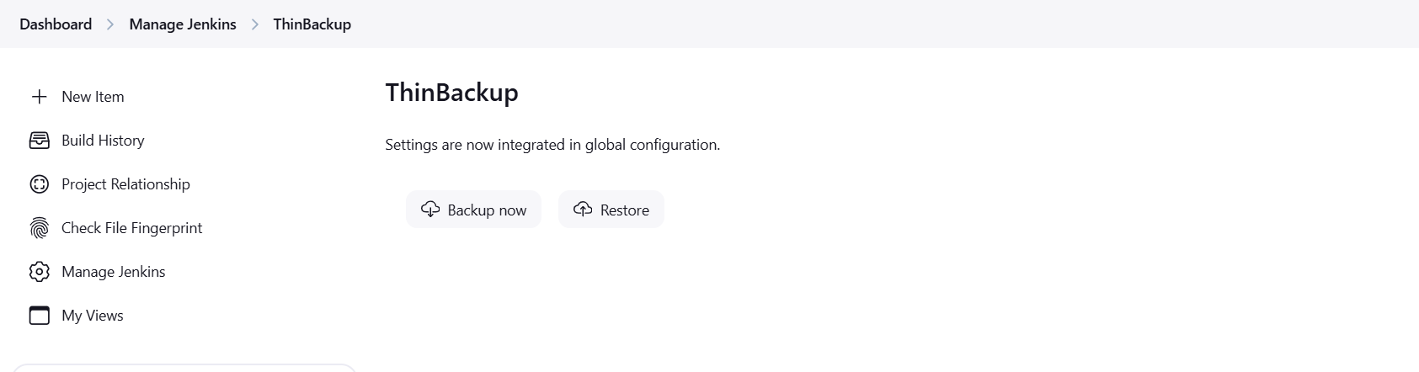
- Setup a new jenkins server and dump the backup taken in task4.

[root@ip-172-31-42-223 lib]# tar -cvf backup.tar jenkins/

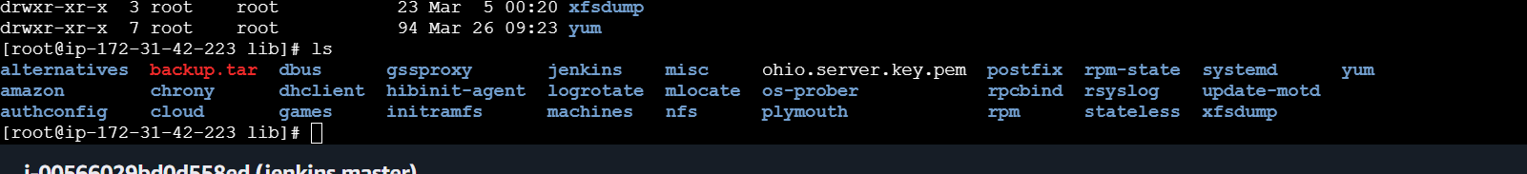

Here I mention the backup server ip in the below command and pemkey given permsion with chmod 7000 ohio.server.key.pem
scp -i ohio.server.key.pem backup.tar ec2-user@13.58.174.58:/tmp

New Jenkins server installed and java jdk and Jenkins is installed now

